EPR WideBand

Antenna Characterization

Testing parameters:

* Agilent Source amplitude: 21 dBm
* Lock-in Mod Frequency: 105 Hz
* Lock-in Sensitivity: 500 pV/nA
* Output Mod current: 21 mA (AC)
* Modulation coils: Helmoltz couple, 230 turns per coil, 0.6 mm copper wire
* Number of averages: 4
* Frequency Limits and sweep points: [2, 20] Ghz, 60 Points
* Field range expressed in mA (on the Yokogawa 7561 source): ±2.5 mA
* Field sweep points: 600 Points
* Temperature: Room Temperature

For each coil, 2 graphs are reported.

The first graph reports the Amplitude of the EPR signal, normalized to the peak value, as a function of the frequency (red line). The graph also reports the Absorption fraction, as estimated by fitting the EPR signal to the sum of a Lorentzian absorption and dispersion line shape. The closer this ratio is to 1, the higher the absorption contribution is. Conversely, a value close to 0 indicates that the dispersion component is dominant.

The second graph reports a map of the signal intensity as a function of frequency and magnetic field, with respect to the resonance field. The absorption fraction is reported on the bottom of the graph for convenience. The dashed black line marks the condition Abs/(Abs+Disp) = 1.

|  |
| --- |
| **1 Turn** |

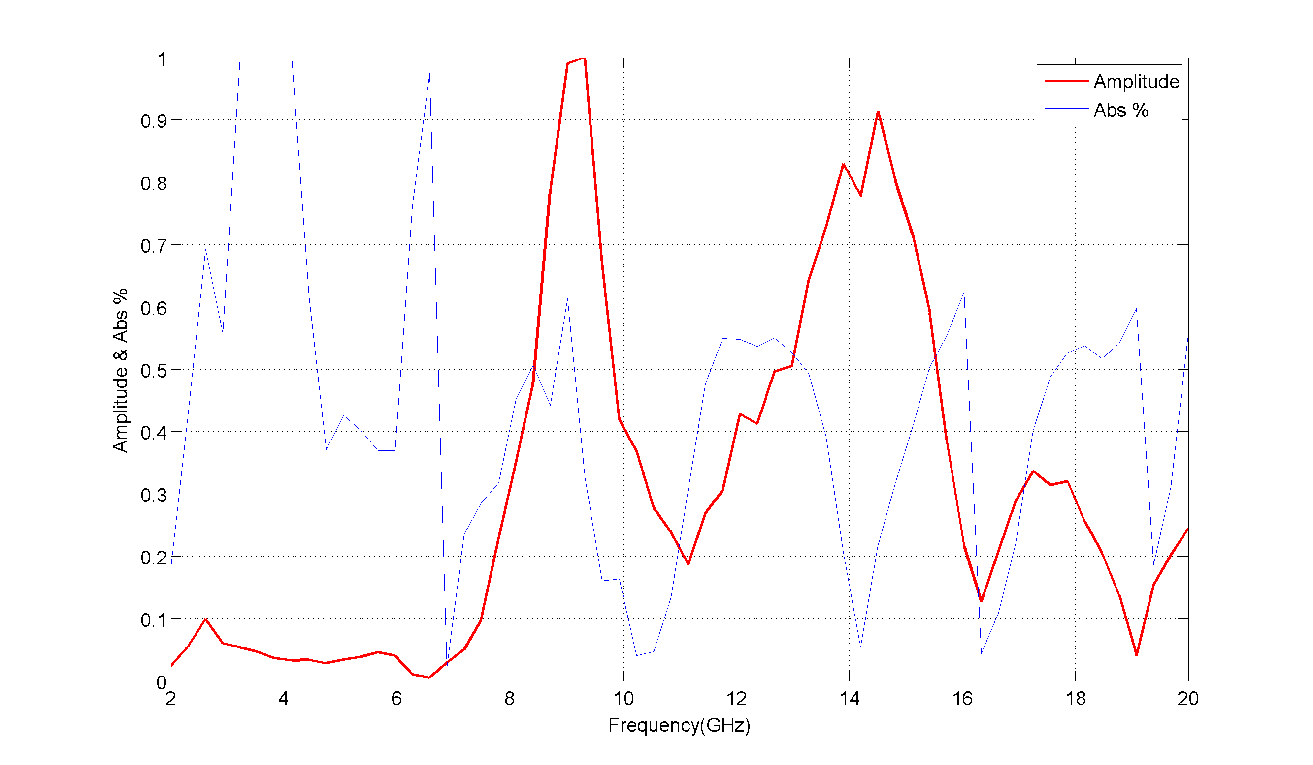

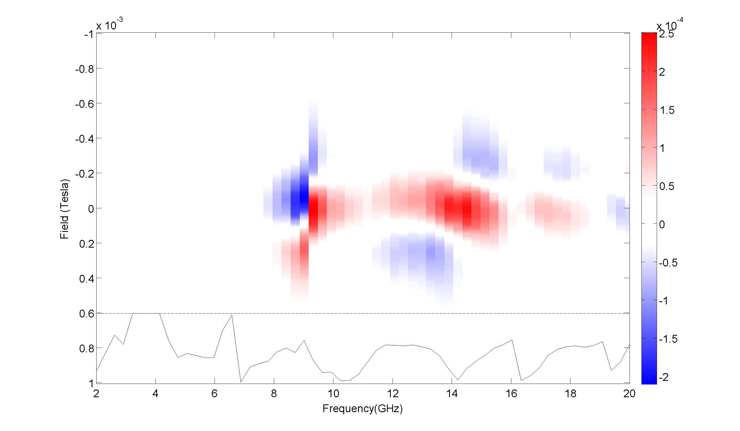

|  |
| --- |
| **3 Turns** |

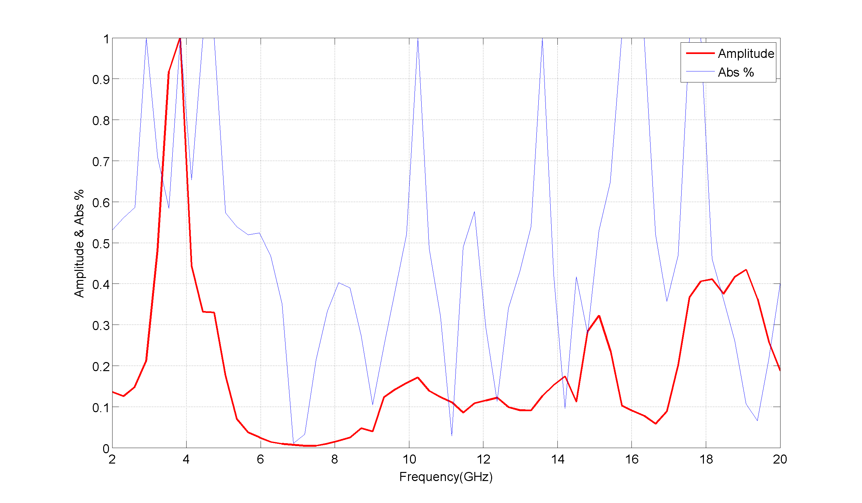

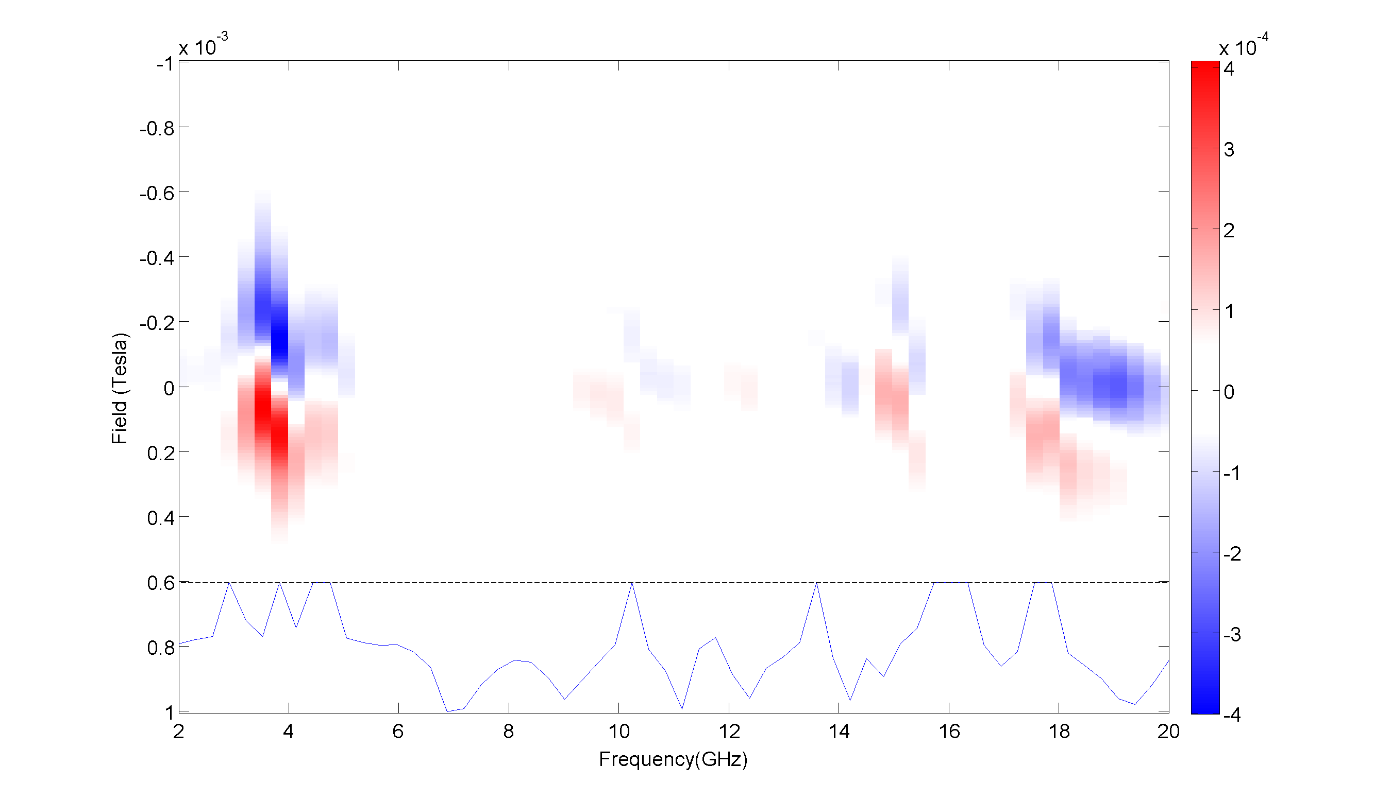

|  |
| --- |
| **5 Turns** |

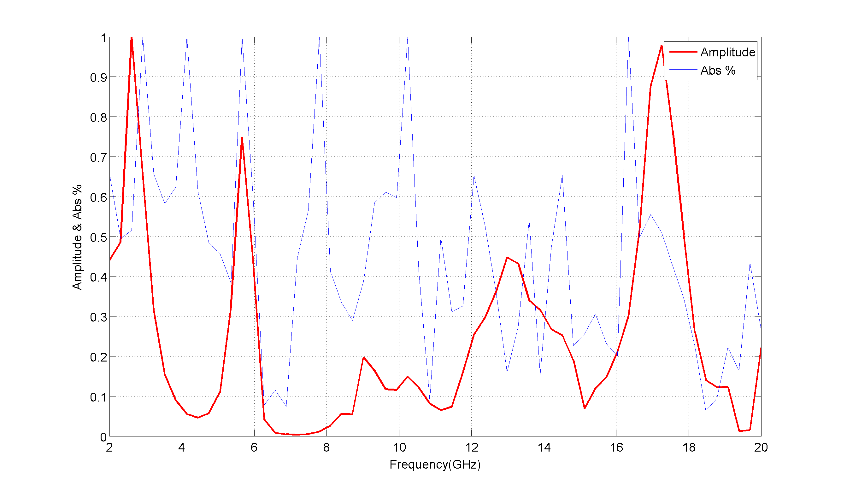

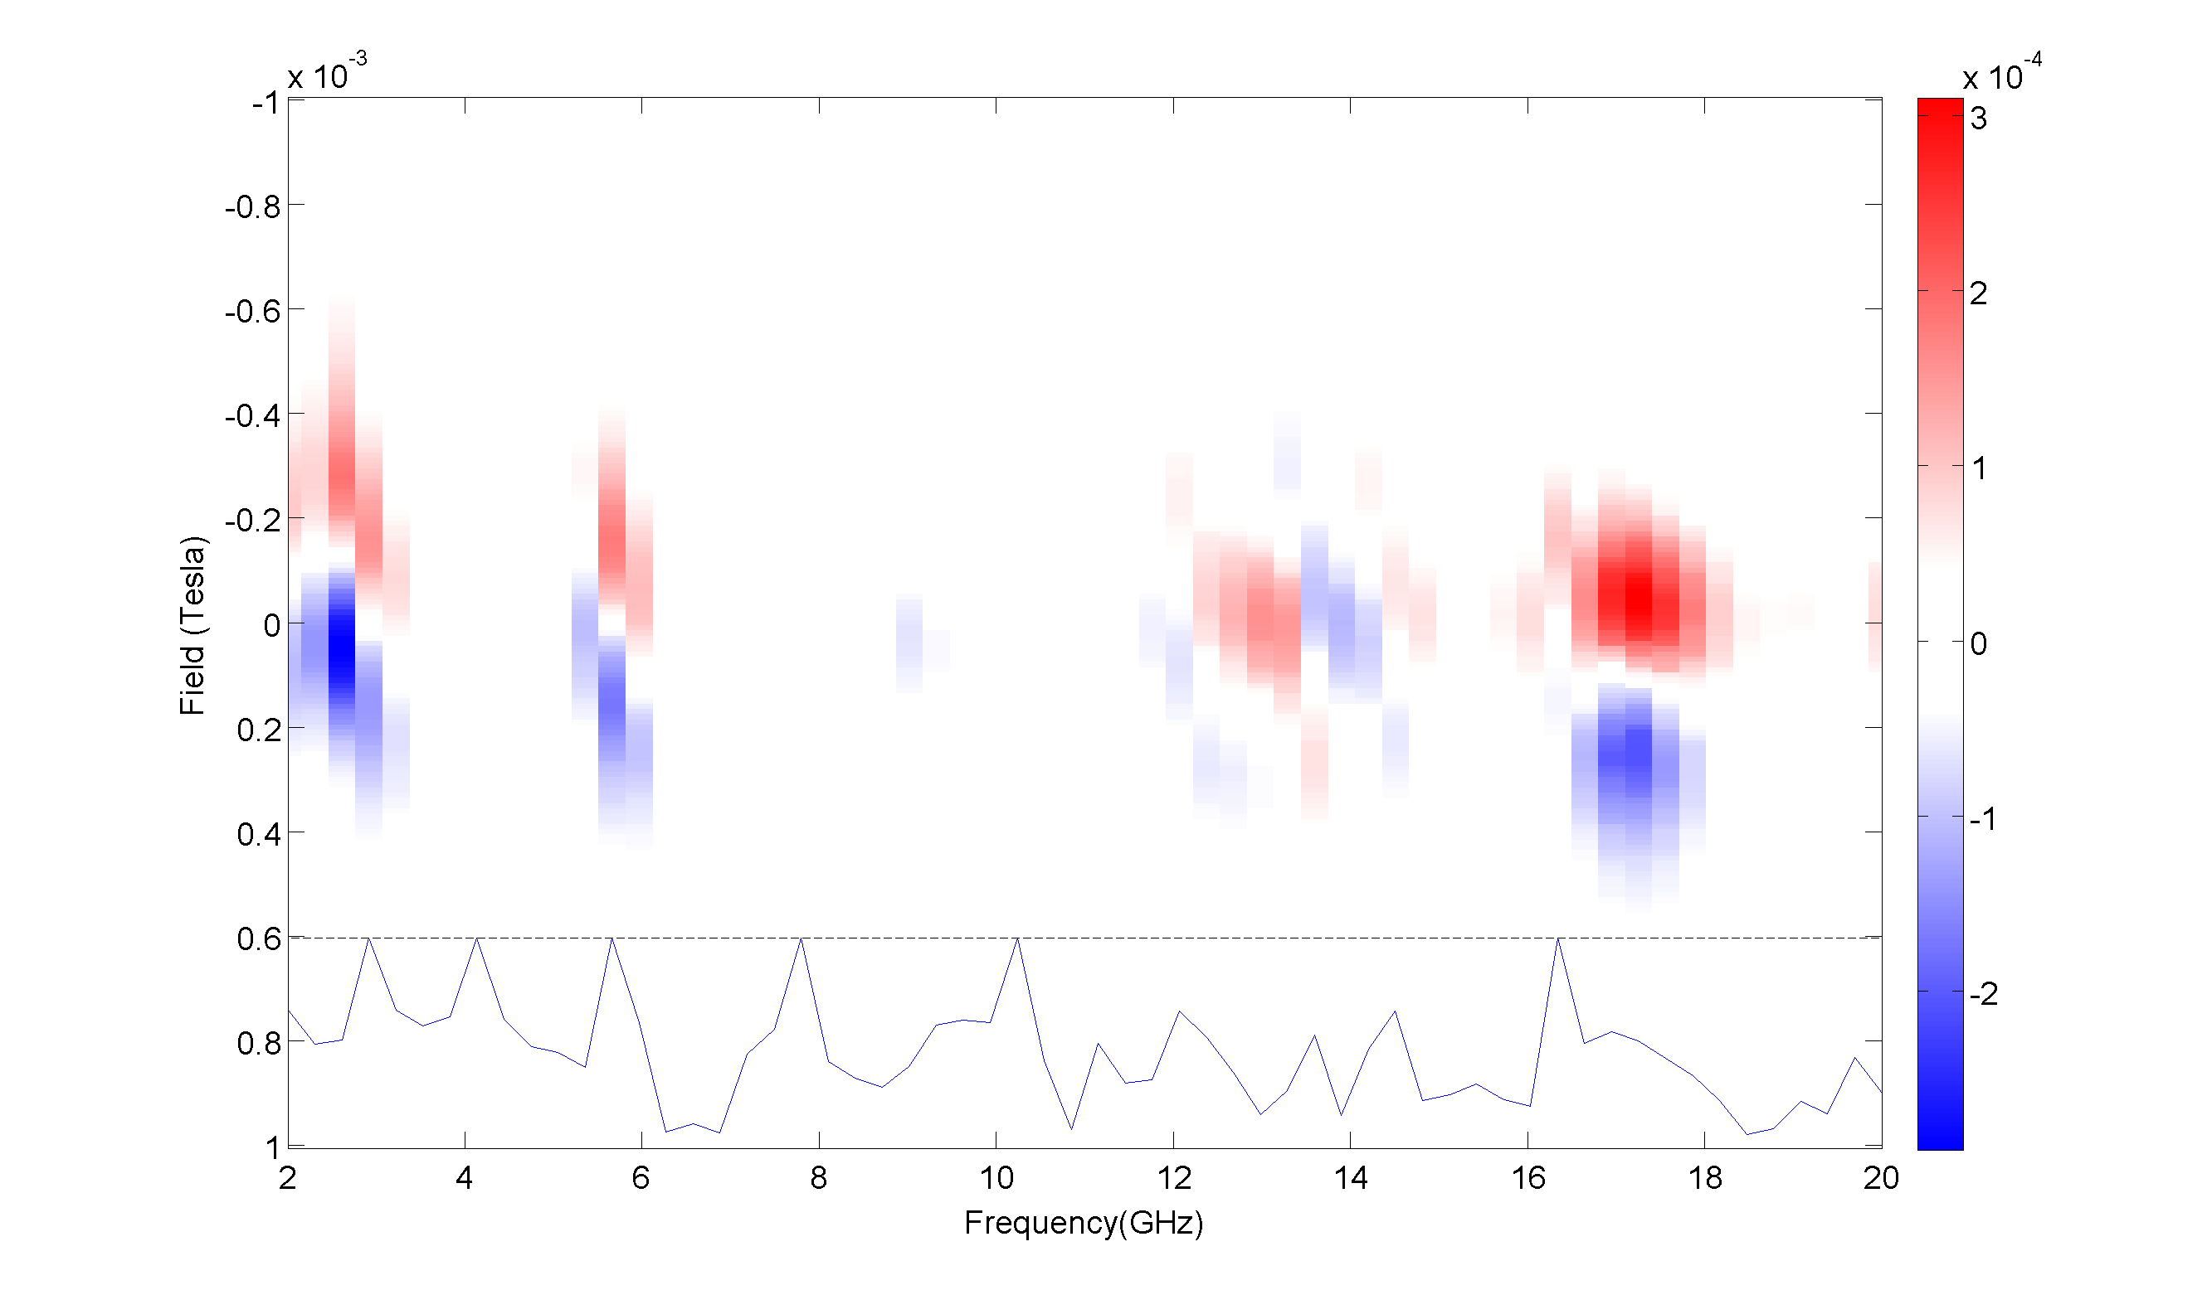

|  |
| --- |
| **7 Turns** |

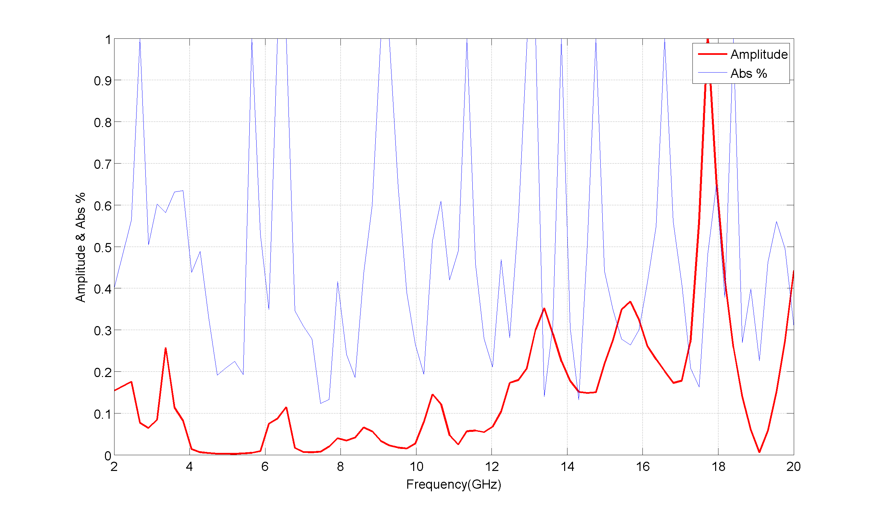

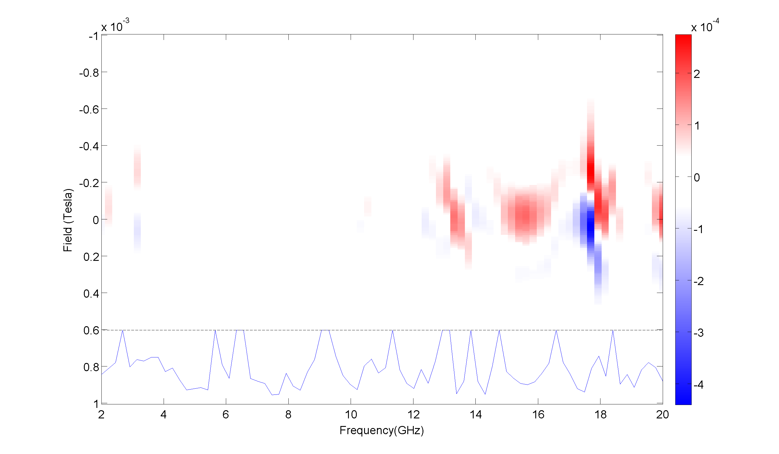

|  |
| --- |
| **9 Turns** |

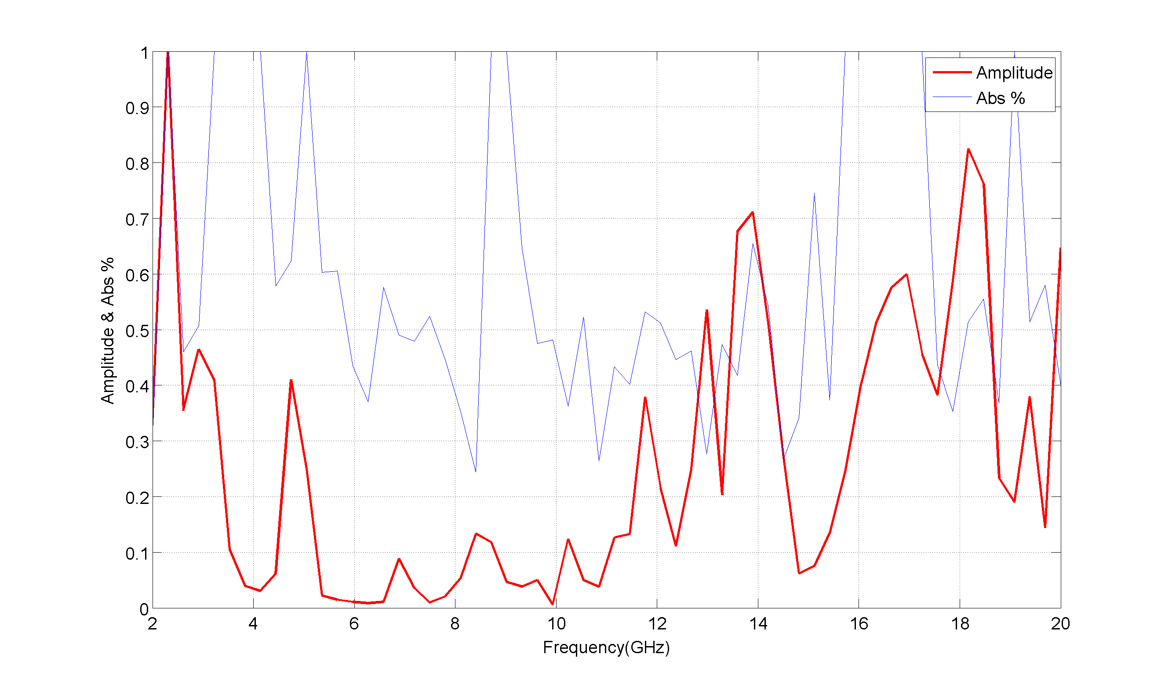

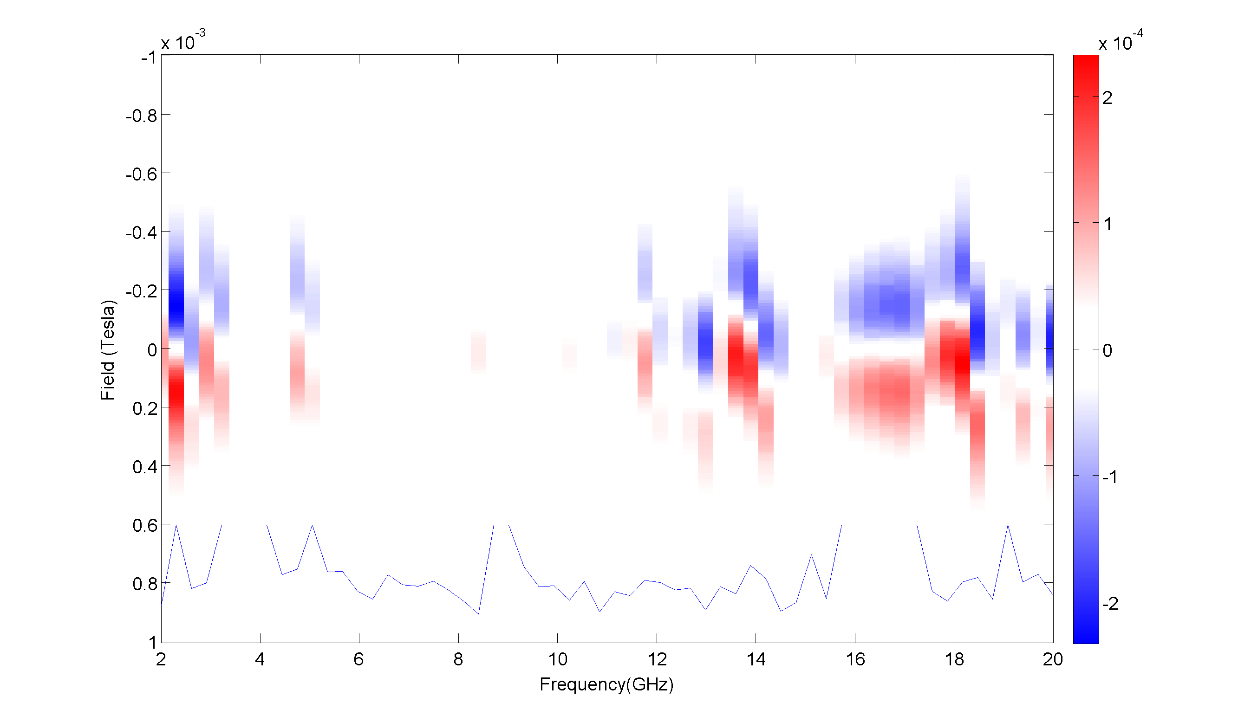

|  |
| --- |
| **All coils: Amplitude vs Frequency** |

